Preparing to Analyze Insulin with Python

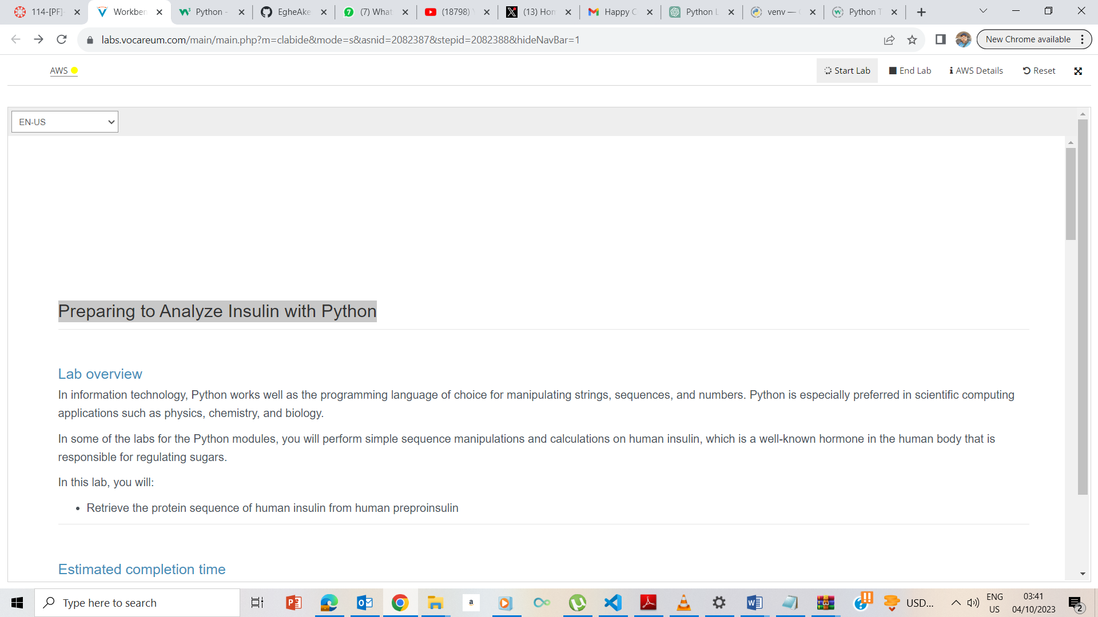

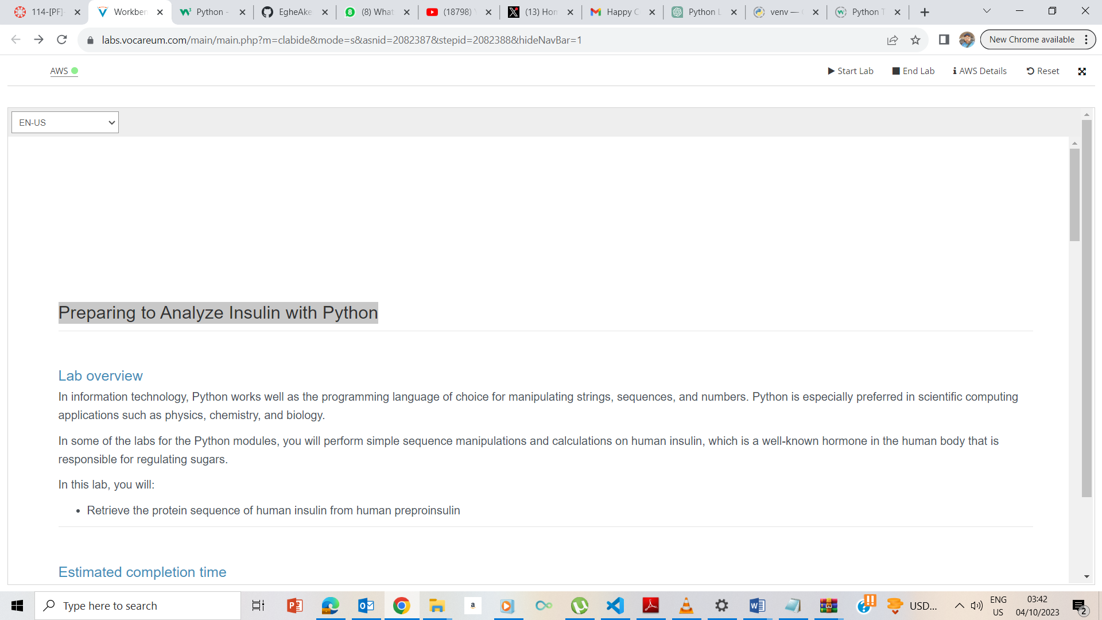

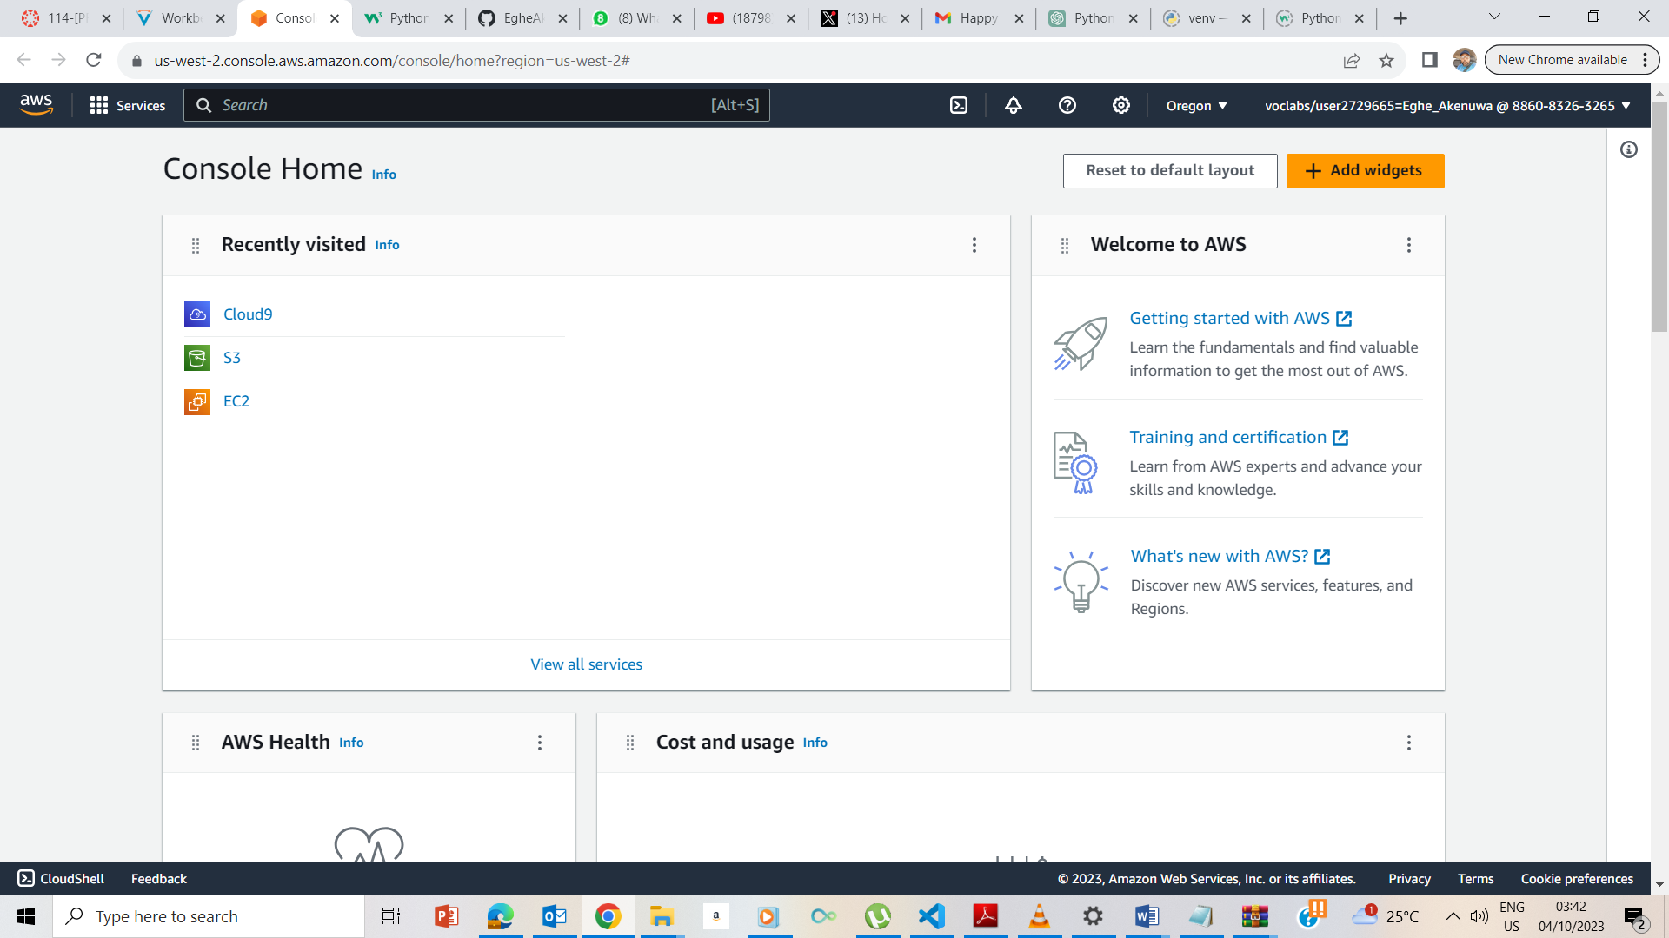

Commencement of the Lab

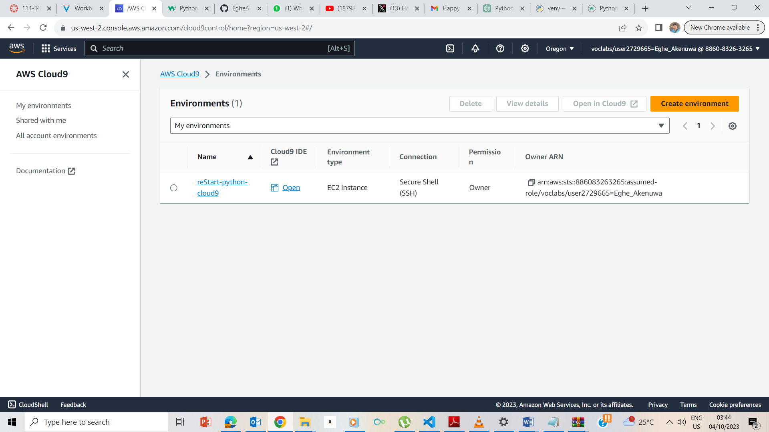

I clicked on Cloud9 to take me to the page and I then click the Open IDE

## **Creating your Python exercise file**

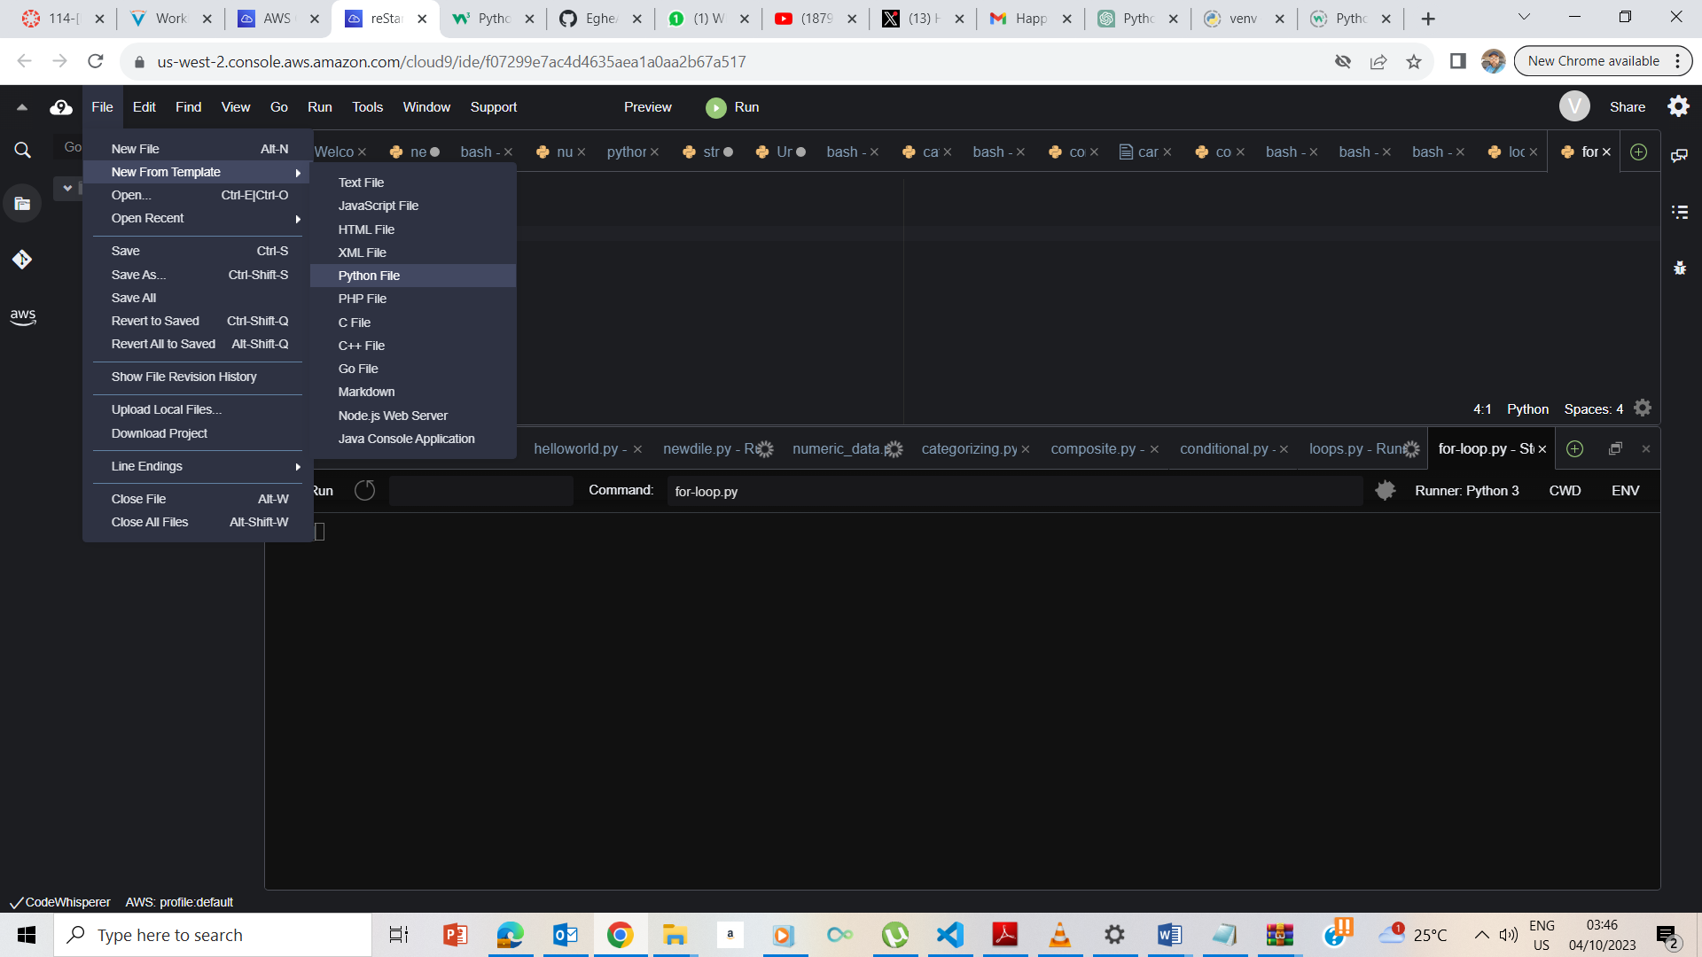

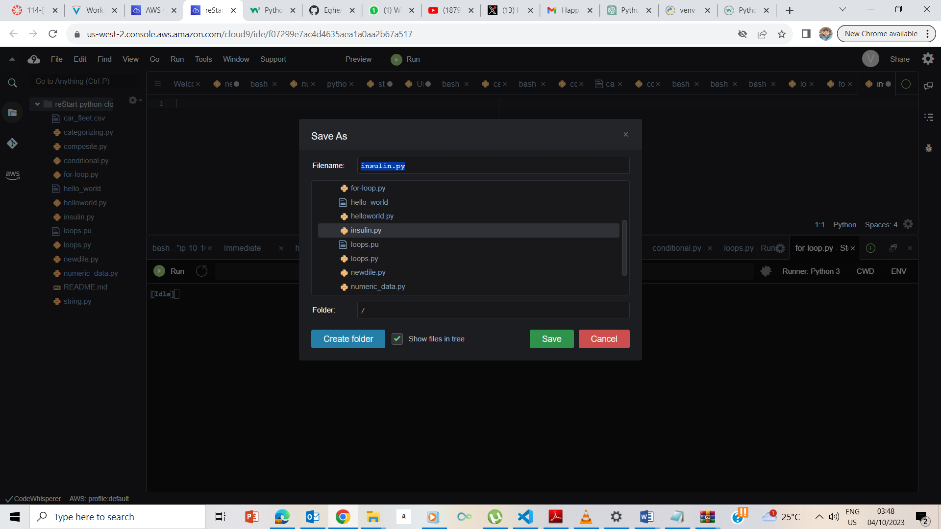

Saved the file in the ec2-user/environment folder.

## **Accessing the terminal session**

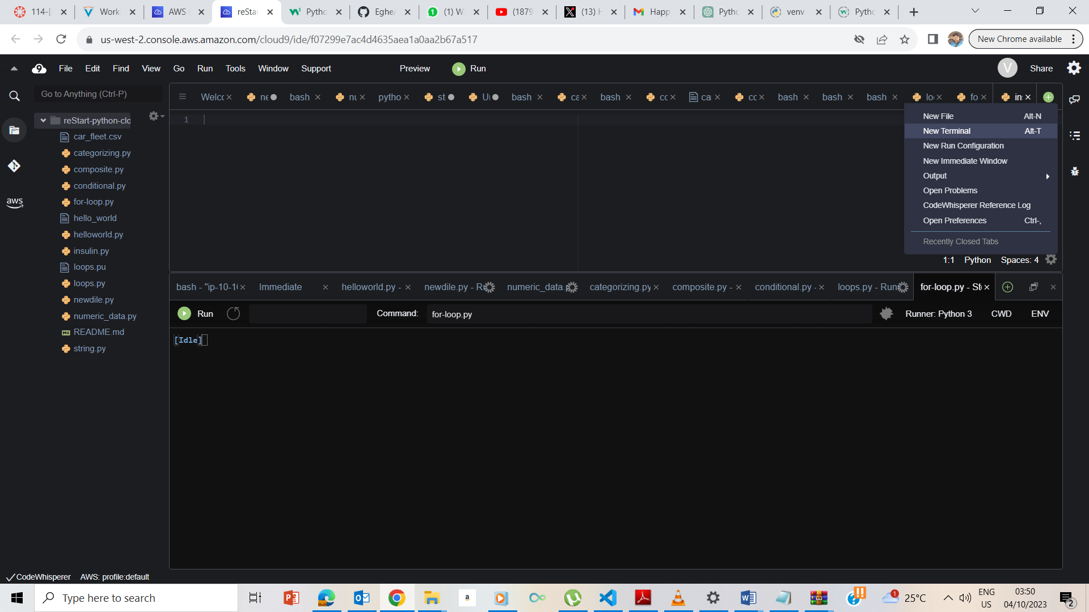

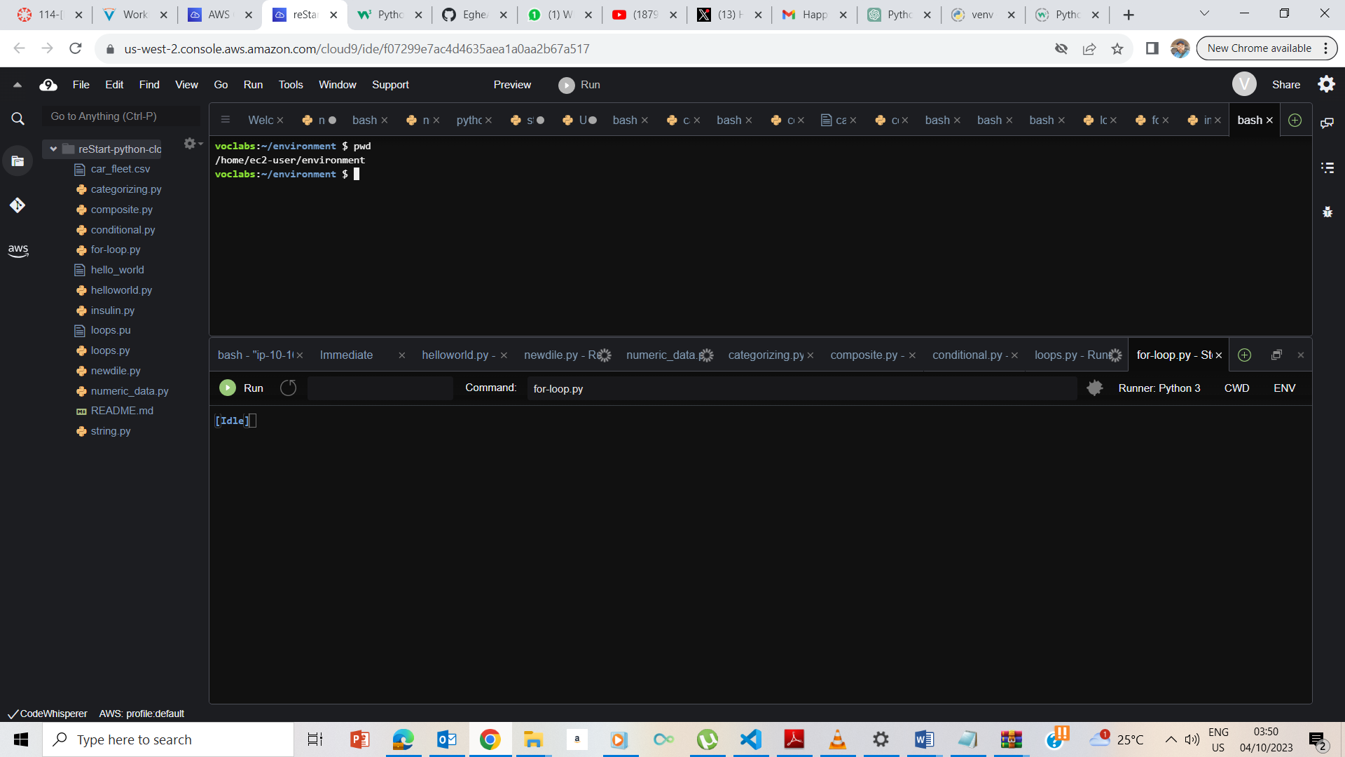

## **Exercise 1: Retrieving the protein sequence of human preproinsulin**

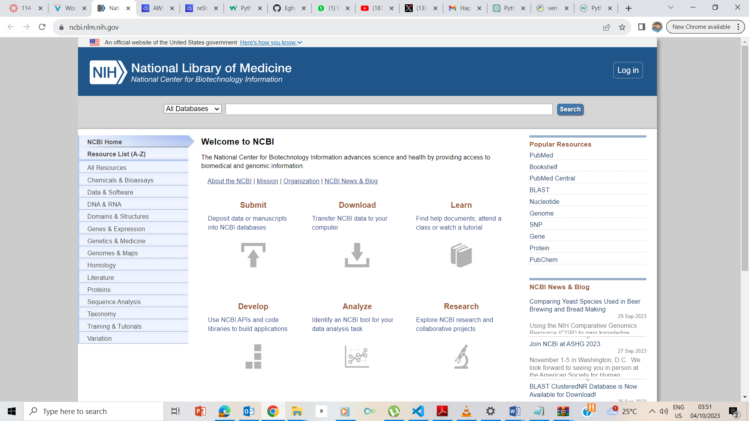

I accessed the website of the organization using the link <https://ncbi.nlm.nih.gov/> provided.

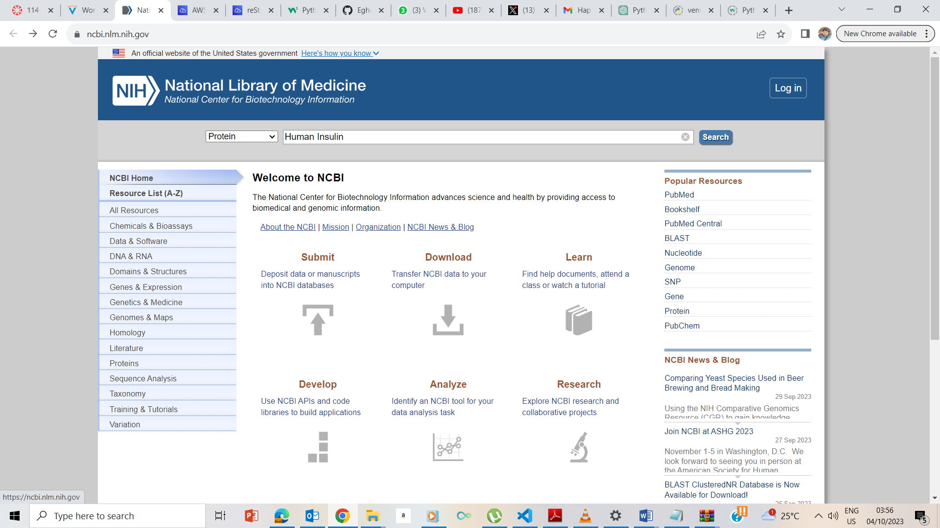

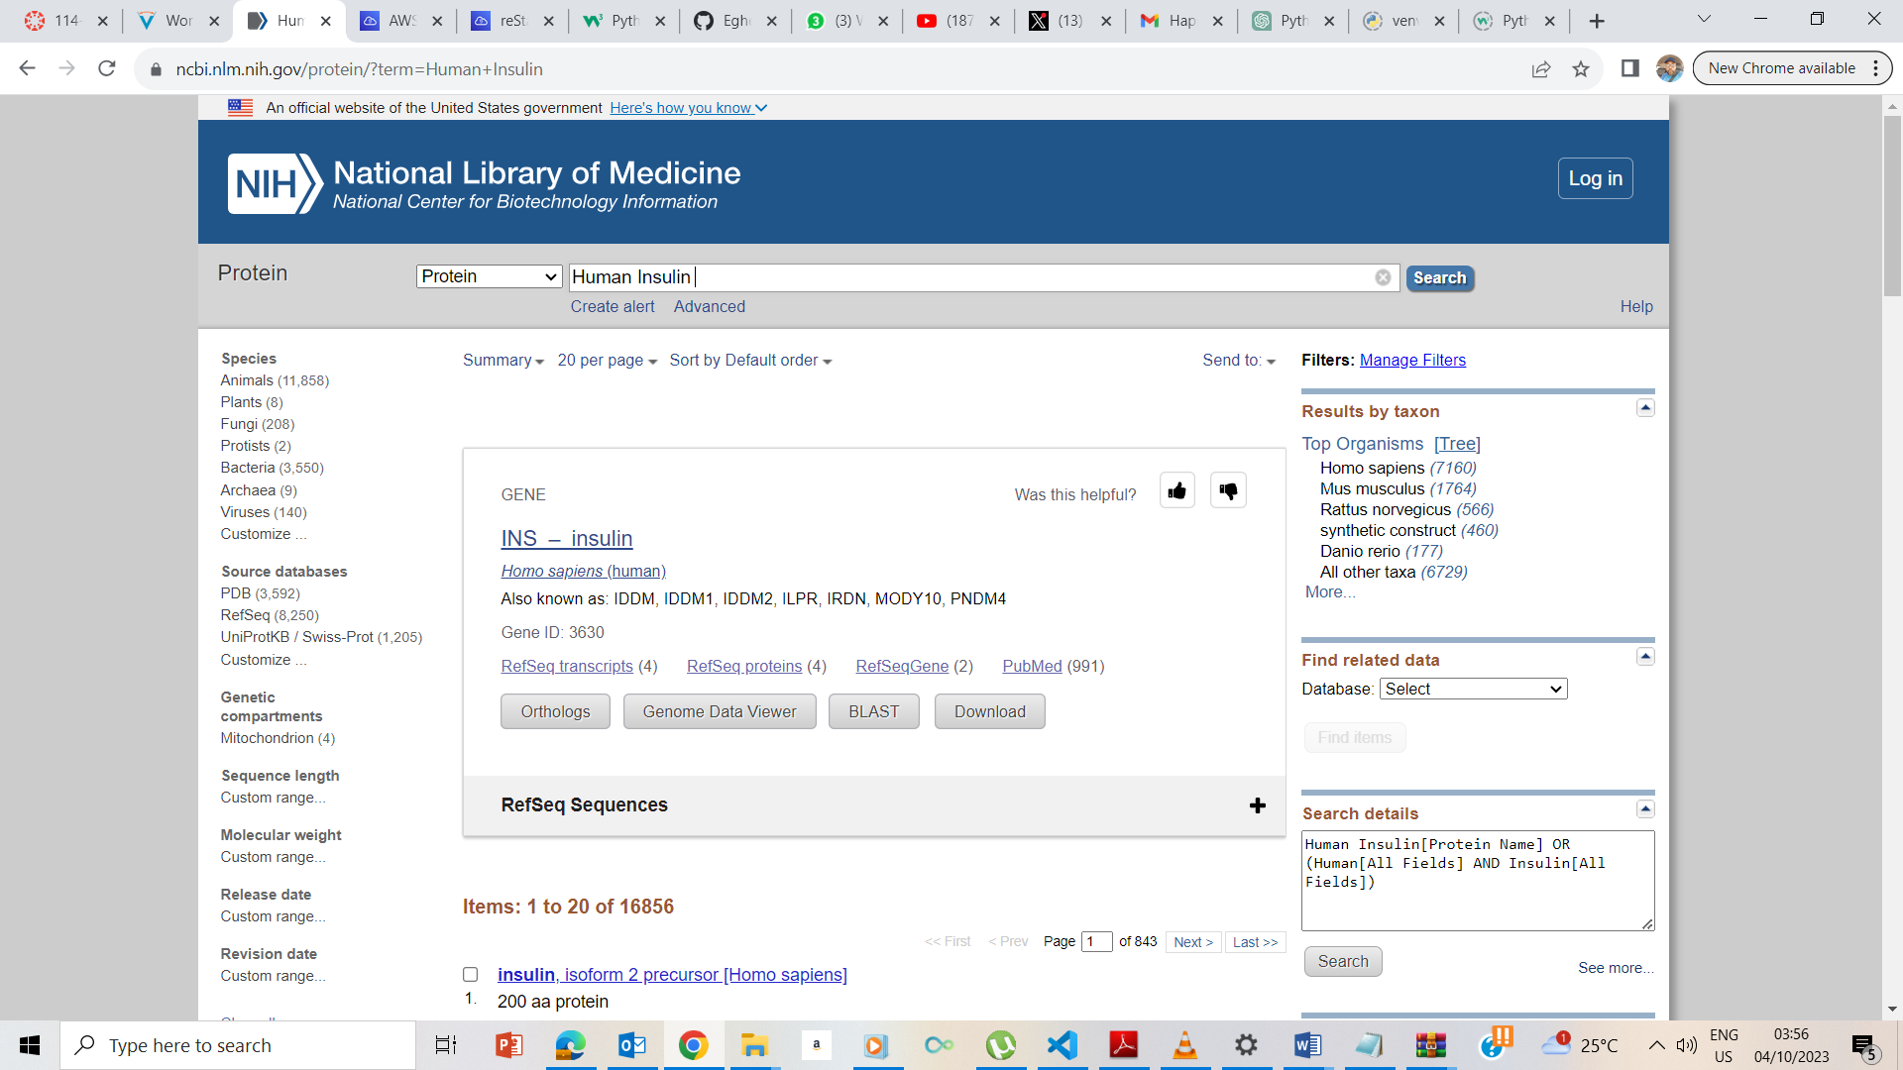

I searched for Human Insulin in Protein Database

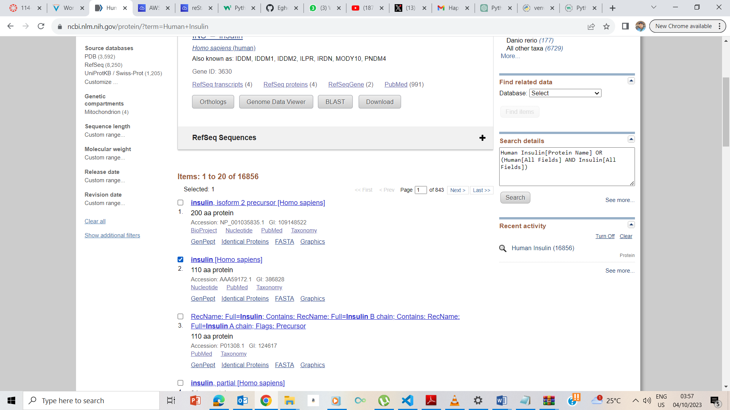

I tick the Insulin (Homo Sapien) box

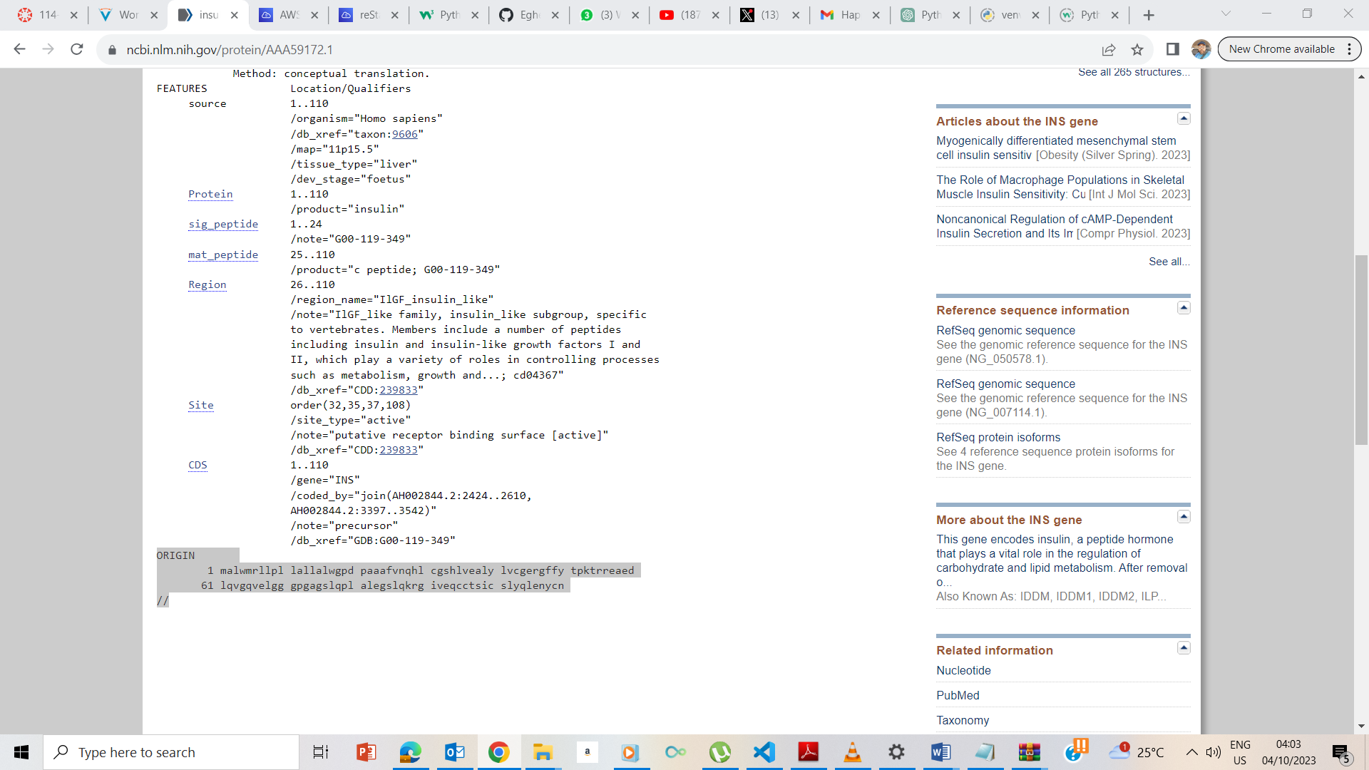

I copy the Insulin sequence which starts with Origin and ends with //

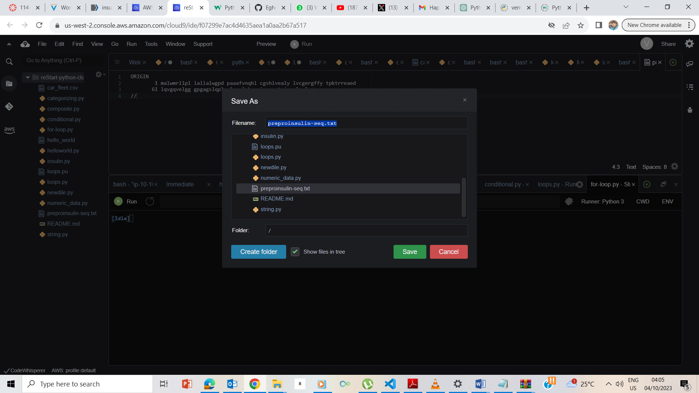

I opened a new terminal on the IIDE and pasted the Sequence I previously copied and saved the file as **preproinsulin-seq.txt**

## **Exercise 2: Obtaining the protein sequence of human insulin**

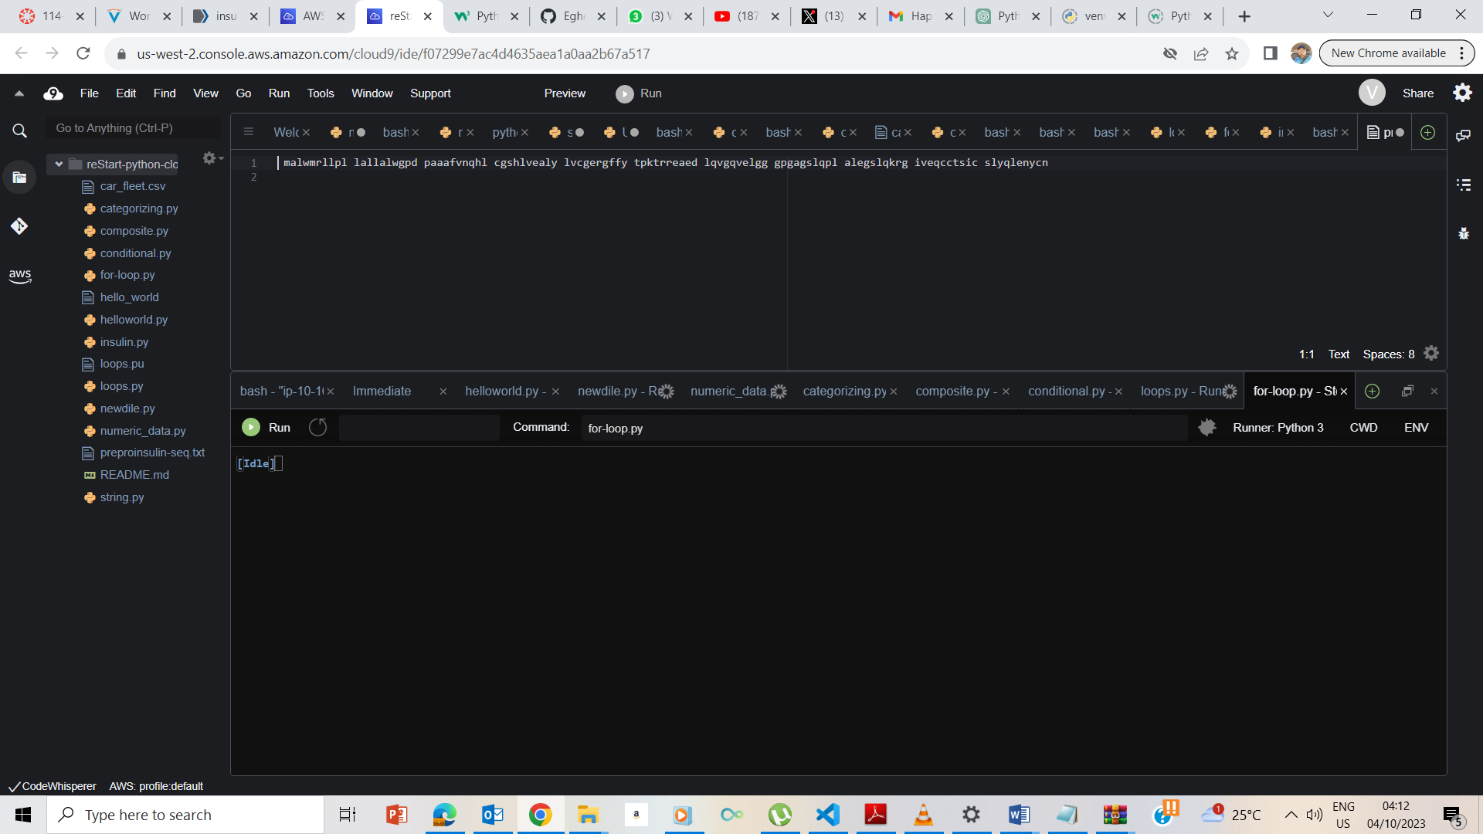

I manually deleted the //, 61, 1 and the spaces and return

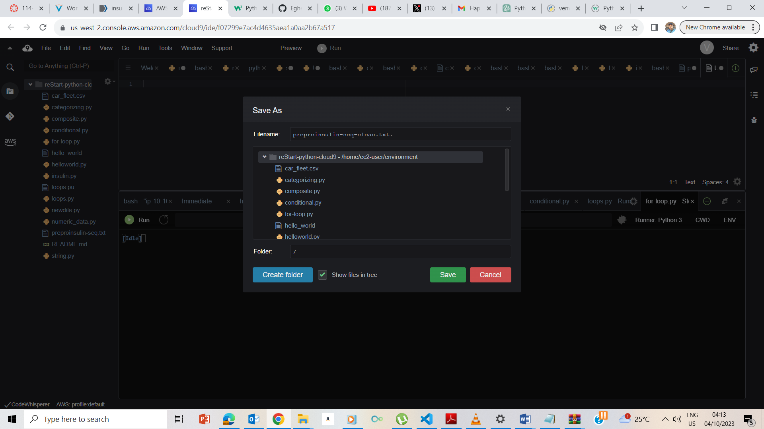

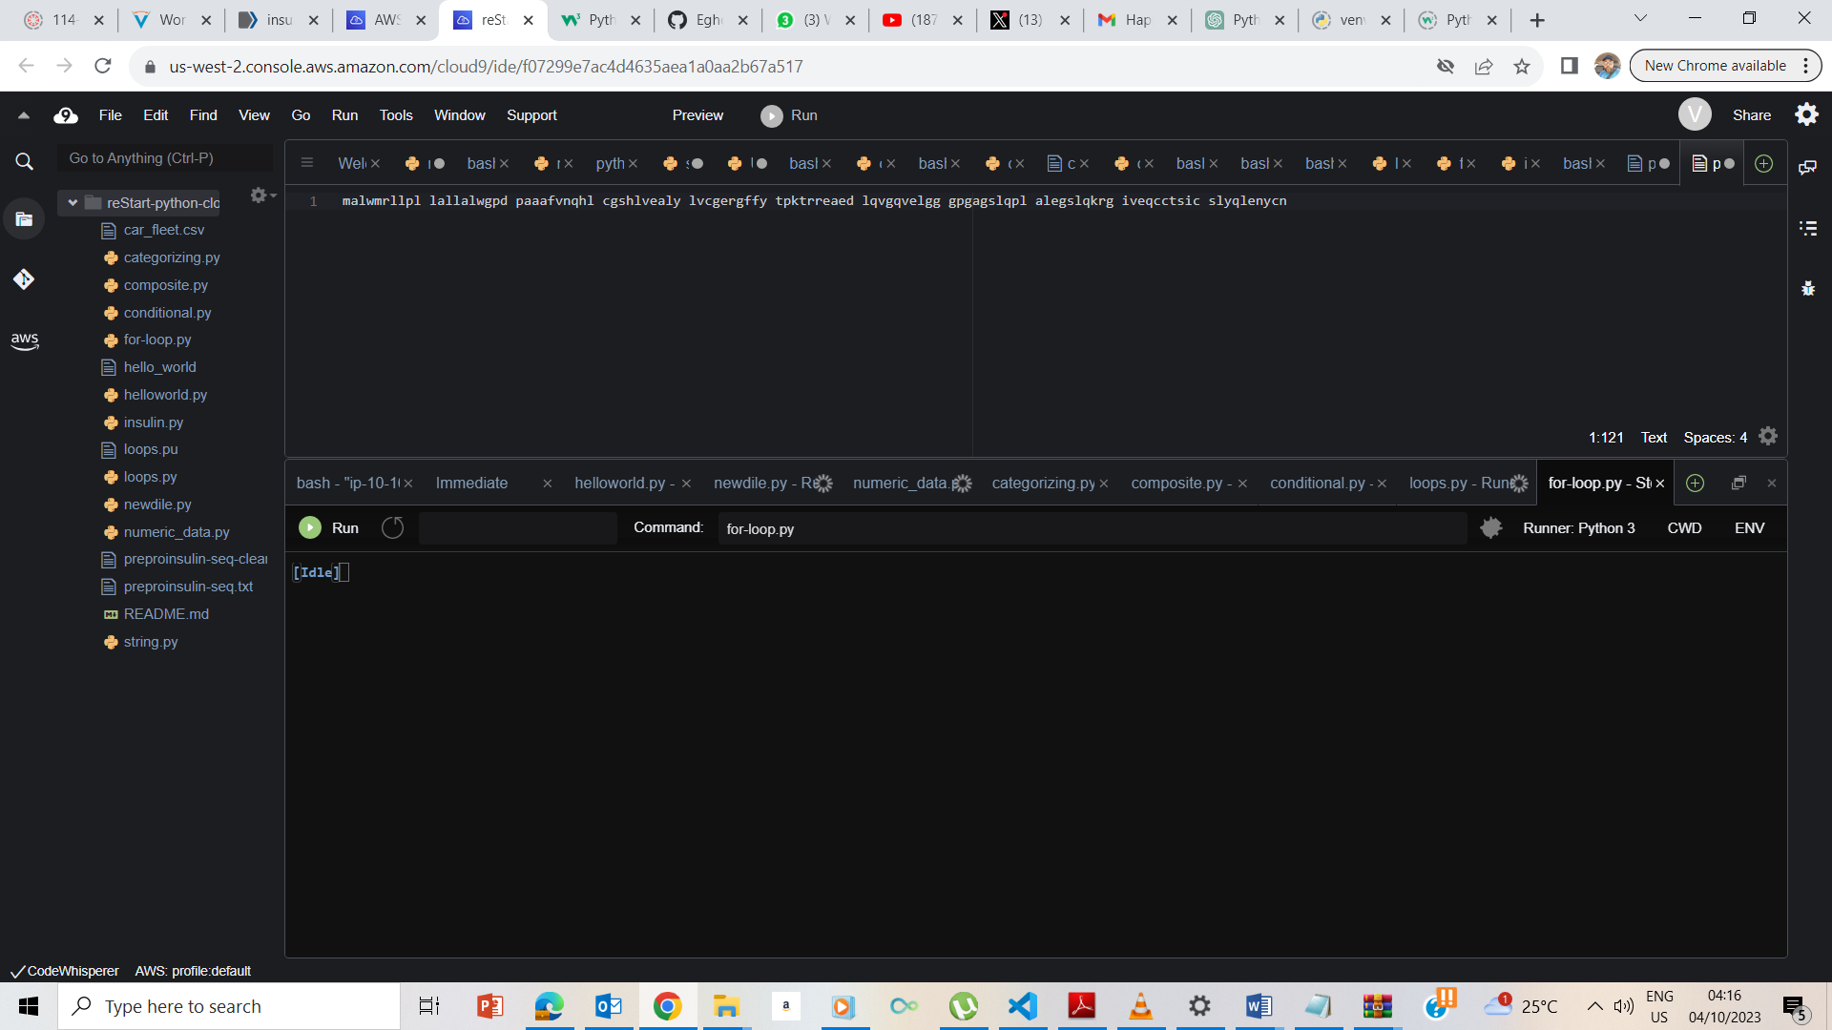

I opened a new file called preproinsulin-seq-clean.txt and copied the result to it.